**Chapter 6 - Animal Reproduction**

**All Lectures Uploaded on YouTube:**

[**https://tinyurl.com/fkm10-biology**](https://tinyurl.com/fkm10-biology)

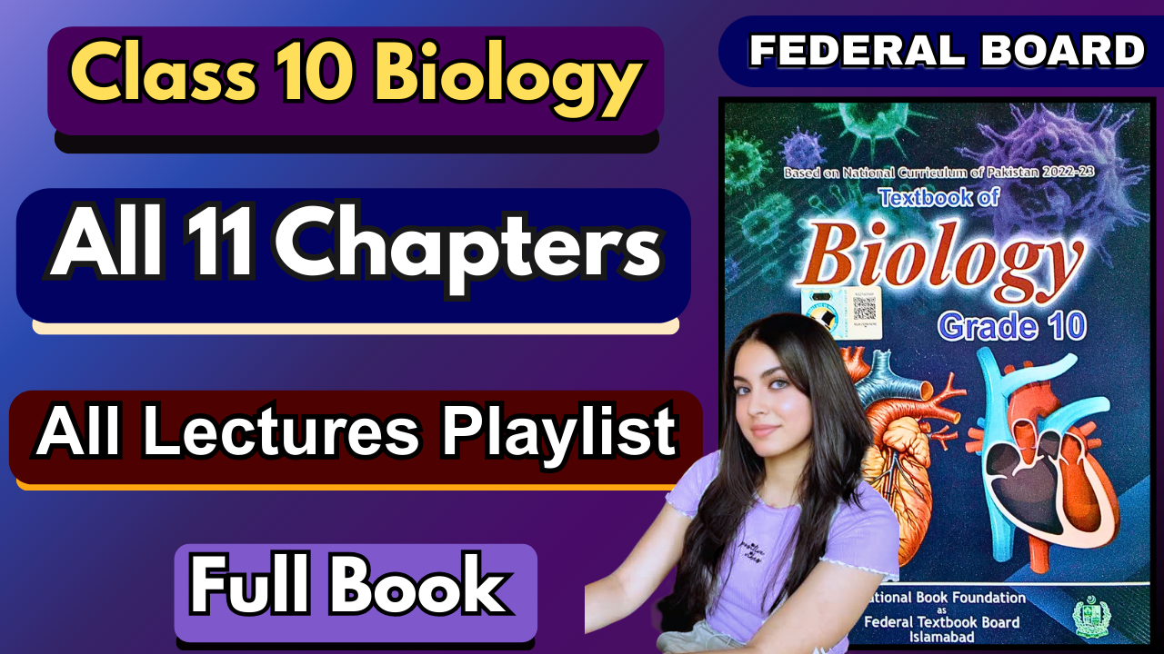

Reproduction is the process by which new individuals are produced from existing ones. It is essential for the survival of a species, though not necessary for the survival of a single organism.

* Two types:

1. **Asexual reproduction**
2. **Sexual reproduction**

We will only focus on **animal reproduction**.

**6.1. Role of Hormones in Male and Female Sexual Development**

### **6.1.1. Male Sexual Development**

**Main hormones:**

* Testosterone
* Follicle Stimulating Hormone (FSH)

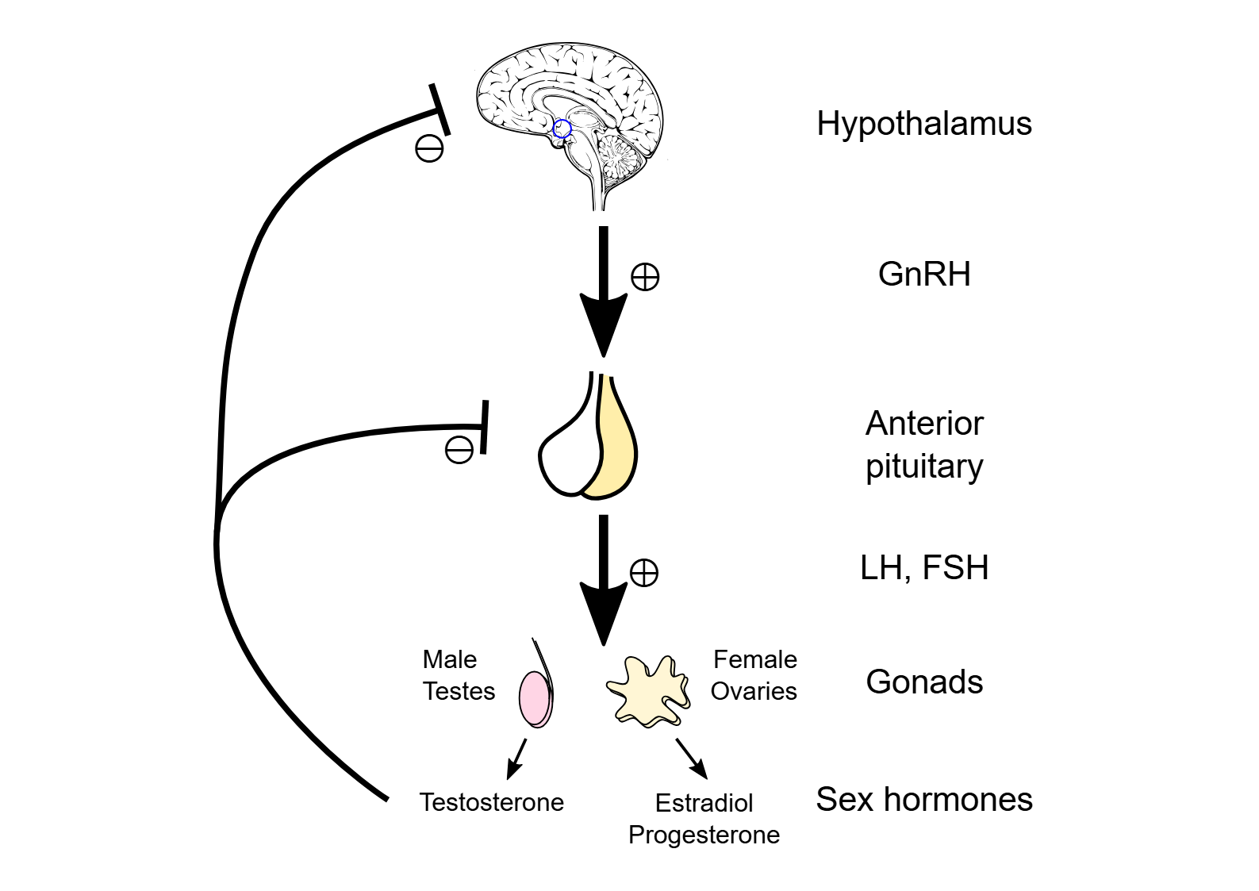

**1) Testosterone**

* Produced in the testes (under control of pituitary gland hormone).
* In females, the same hormone is called **Luteinizing Hormone (LH/ICSH)**.
* Functions:
  + Development of male reproductive organs during puberty.
  + Controls spermatogenesis and reproductive system maintenance.
  + Stimulates sperm development into mature sperms.
  + Promotes secondary sexual characteristics:
    - Beard and body hair growth
    - Deepening of voice
    - Increased muscle mass

**2) Follicle Stimulating Hormone (FSH)**

* Produced by anterior pituitary gland.
* Stimulates testes cells for sperm development and regulates sperm production.
* Acts at a different stage from testosterone:
  + **Testosterone** → final maturation of sperm
  + **FSH** → initiation and regulation of early sperm development

### **6.1.2. Female Sexual Development**

**Main hormones:**

* Estrogen
* Follicle Stimulating Hormone (FSH)
* Luteinizing Hormone (LH)
* Progesterone

**1) Estrogen**

* Produced by ovarian follicles under FSH influence.
* Functions:
  + Development of female reproductive organs (uterus, fallopian tubes, etc.)
  + Secondary sexual characteristics during puberty.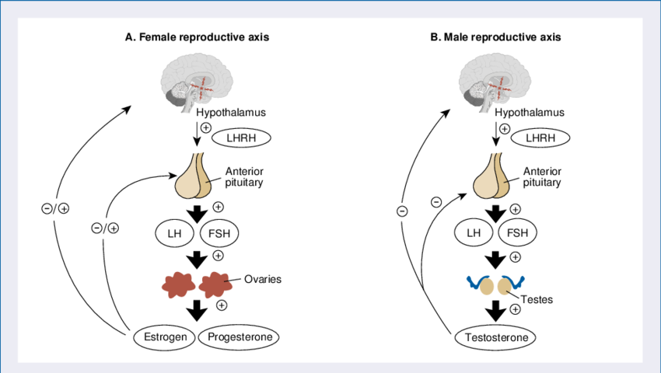

**2) Follicle Stimulating Hormone (FSH)**

* Produced by anterior pituitary gland.
* Stimulates growth of ovarian follicles.
* Promotes **oogenesis** (egg formation).
* Helps in estrogen production and prepares body for ovulation.

**3) Luteinizing Hormone (LH)**

* Produced when high estrogen levels inhibit FSH secretion.
* Causes rupture of mature follicle → ovulation.
* After ovulation:
  + The follicle becomes **Corpus Luteum**
  + Corpus luteum produces progesterone

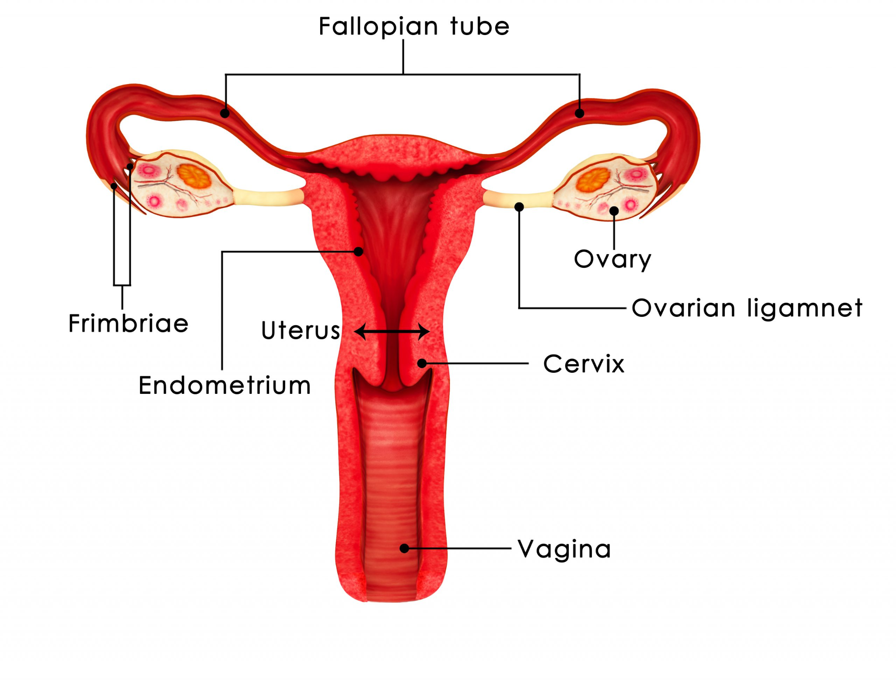

**4) Progesterone**

* Produced by **Corpus Luteum**.
* Functions:
  + Prepares uterus lining for embryo implantation.
  + Maintains pregnancy.
  + High levels inhibit the release of more eggs.

## **6.2. Gametogenesis and Fertilisation**

## **6.2.1. Gametogenesis**

* Process of gamete (sperm/egg) formation through **meiosis**.
* Reduces chromosome number by half (haploid).
* Ensures **genetic variation** through crossing over and independent assortment.

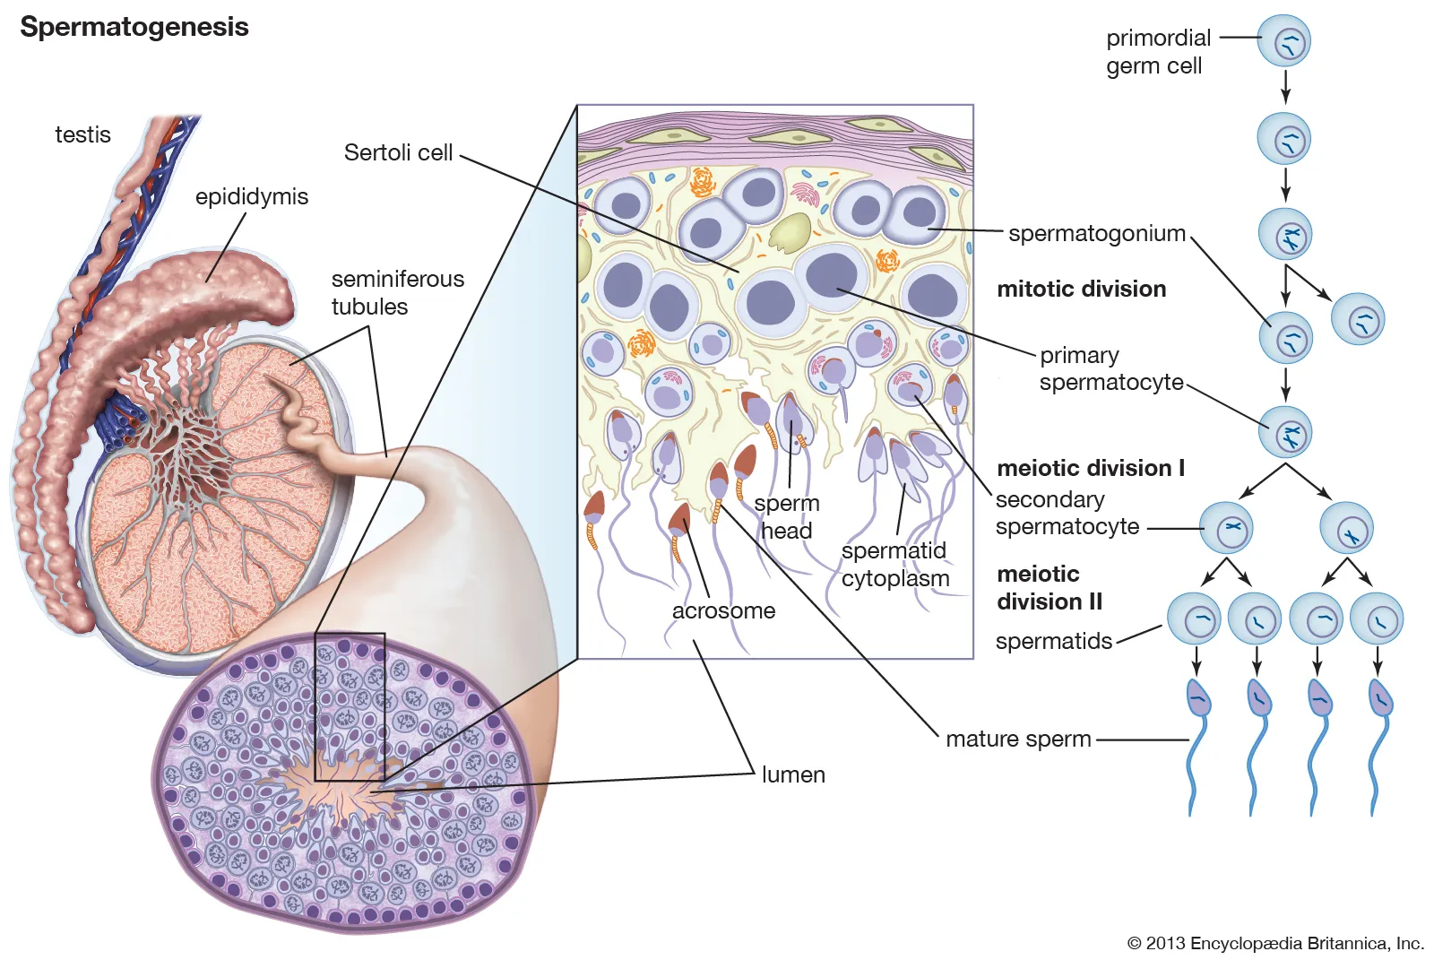

**In males → Spermatogenesis**

* Location: Testes
* Continuous process after puberty
* Steps:
  1. **Spermatogonia (2n)** → divide by mitosis → primary spermatocytes
  2. **Primary spermatocyte (2n)** → meiosis I → two secondary spermatocytes (n)
  3. **Secondary spermatocyte (n)** → meiosis II → four spermatids (n)
  4. **Spermatids** → differentiate into mature spermatozoa (spermiogenesis)
  5. **Formation of sperm** from spermatids

**In females → Oogenesis**

* Location: Ovaries
* Cyclic process (occurs once per reproductive cycle).
* Begins before birth:
  + Oogonia (2n) → primary oocytes (arrested in prophase I until puberty).
* At puberty:
  + Meiosis I resumes → forms secondary oocyte + polar body.
  + Secondary oocyte arrested in metaphase II until fertilization.
  + Meiosis II completes only if sperm enters.
  + Results: 1 ovum + 3 polar bodies (which degenerate).

### 

### 

### **6.2.2. Fertilization**

* **Definition:** Union of sperm (male gamete) and egg (female gamete) which forms a **zygote**.
* Restores diploid chromosome number (46 in humans).
* Each parent contributes **23 chromosomes**.

**Types:**

1. **Internal Fertilization**
   * Inside the female body.
   * Fewer offspring, higher survival.
   * Parental care is common.
   * Found in: mammals, birds, reptiles.
2. **External Fertilization**
   * Outside the female body (in water).
   * Many offspring, lower survival.
   * Little/no parental care.
   * Found in: fish, amphibians, aquatic invertebrates.

**Modes of Development after Fertilisation:**

* **Viviparous** – young develop completely inside the mother (mammals).
* **Oviparous** – eggs laid outside the body (birds, reptiles, amphibians).
* **Ovoviviparous** – eggs hatch inside the mother, young are released alive (sharks, rays).

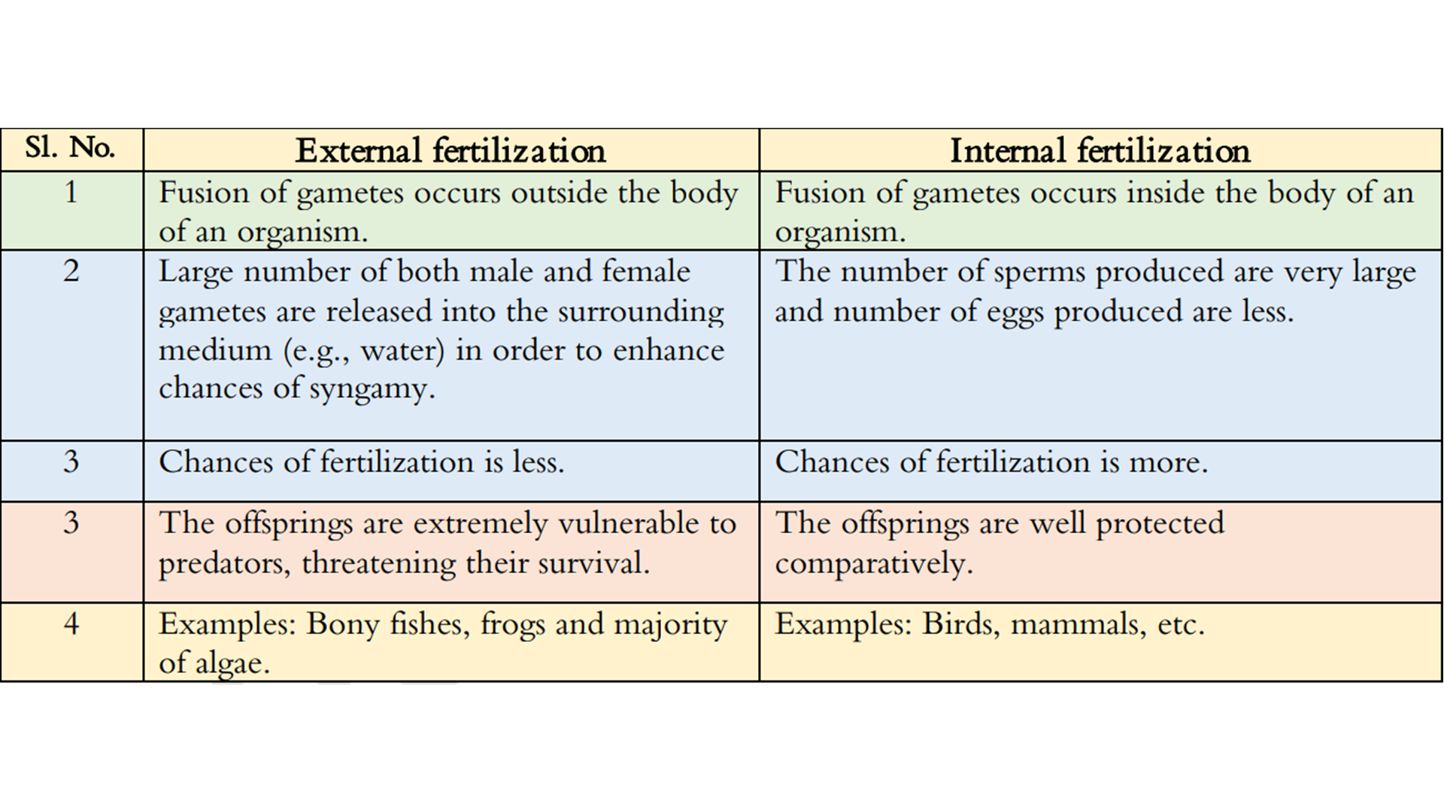

## **6.3. Mechanism of Reproduction in Animals**

### **6.3.1. Asexual Reproduction**

* Single parent → identical offspring (clones).
* No gametes involved.
* Common in invertebrates and unicellular organisms.
* Examples: budding, fragmentation, regeneration, and binary fission.
* **Advantage:** Rapid population increase; useful when mates are not available.
* **Disadvantage:** Lack of genetic diversity → more vulnerable to diseases and environmental changes.

#### **Types of Asexual Reproduction**

1. **Binary Fission**
   * The parent cell splits into **two equal daughter cells**.
   * Common in protozoans like *Amoeba* and *Paramecium*.
   * Process: Parent cell → nucleus divides (mitosis) → cytoplasm divides → 2 identical daughter cells.

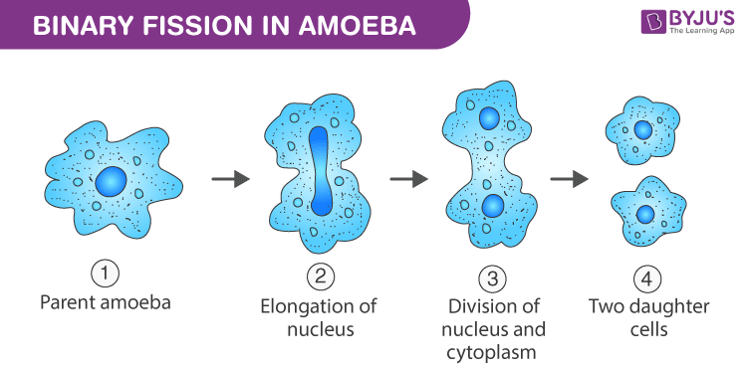

1. **Budding**
   * A **small bud** forms on the parent body by mitosis.
     1. The bud grows, develops, and detaches to become a new individual.
     2. Example: Hydra.

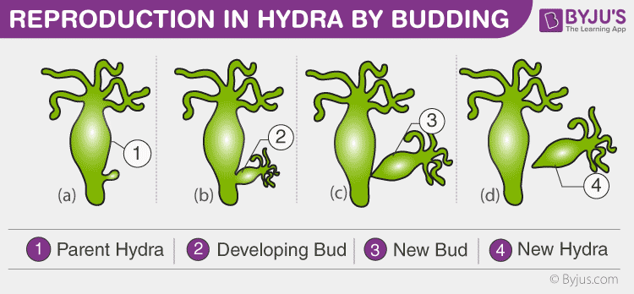

3. **Fragmentation and Regeneration**

* + 1. The parent body breaks into two or more fragments.
    2. Each fragment regenerates into a complete individual.
    3. Example: Planaria, Starfish.

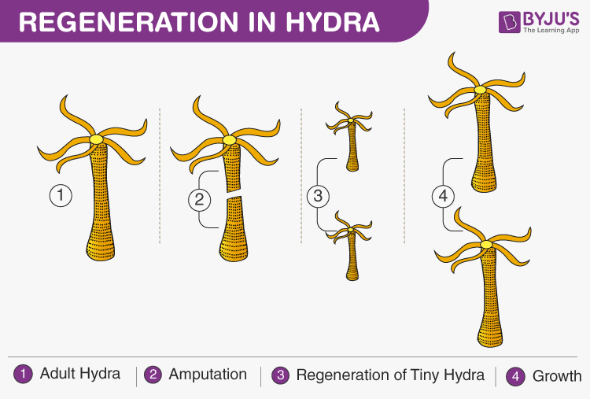

4**. Parthenogenesis**

* + 1. Development of a new individual from an unfertilized egg.
    2. Common in some insects (e.g., bees).
    3. Example: Queen bee (2n) produces eggs → unfertilized eggs develop into drones (males).

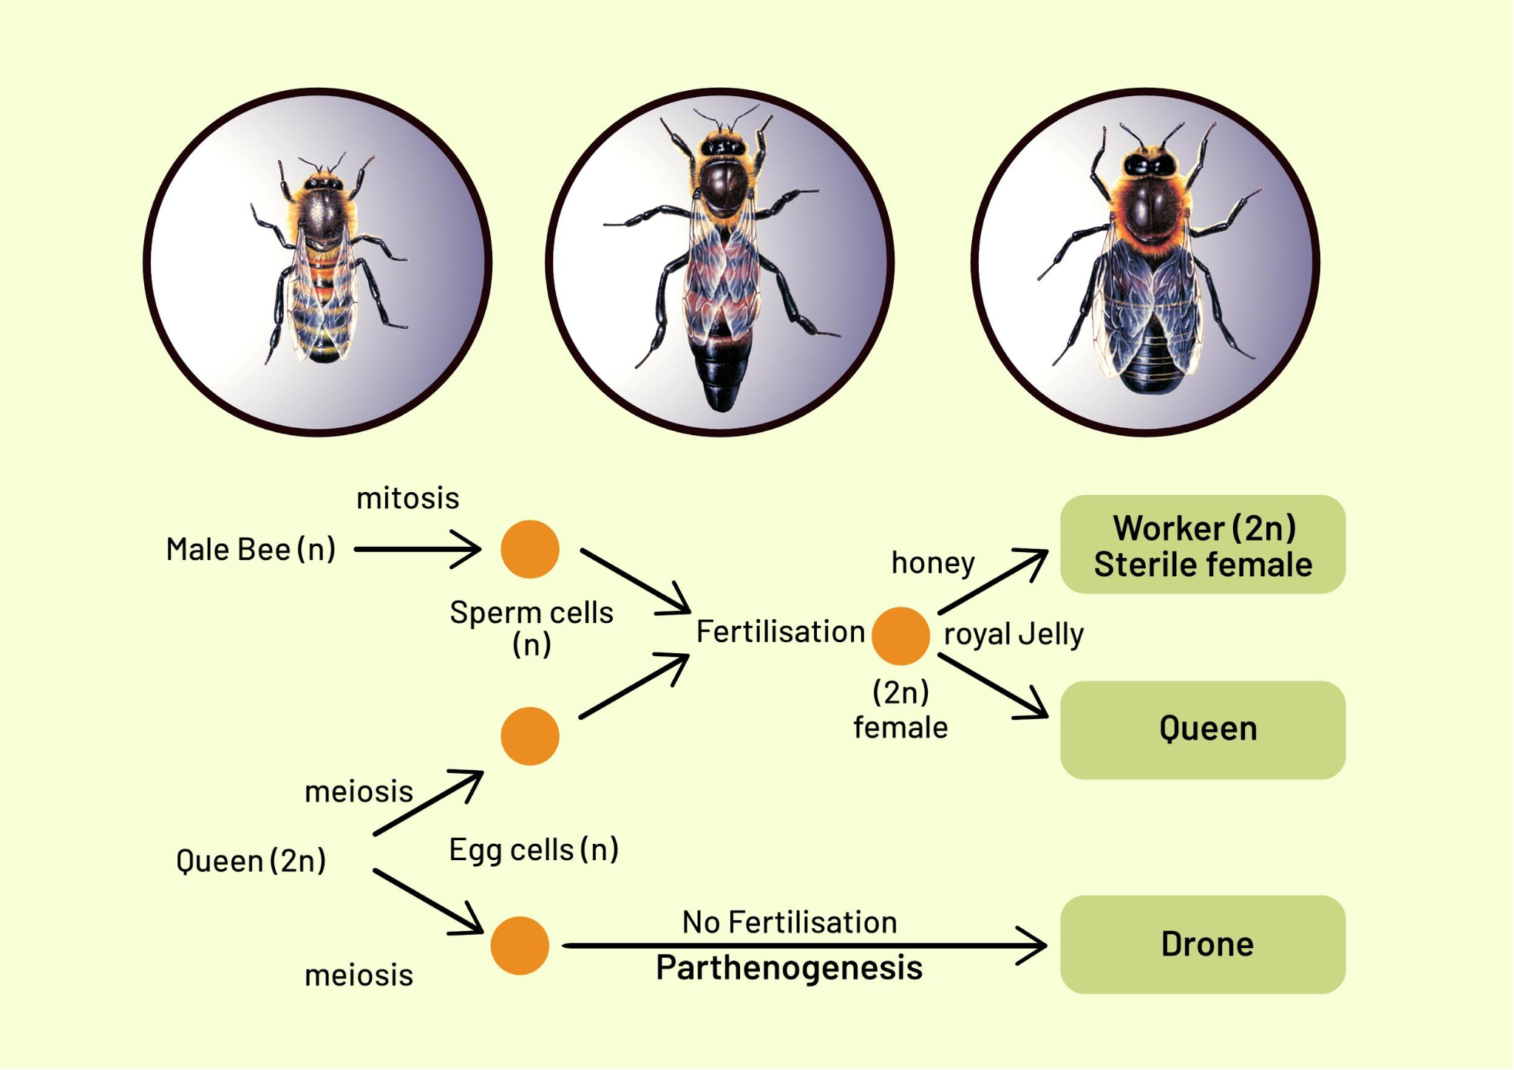

### **6.3.2. Sexual Reproduction in Animals**

* Most animals are dioecious (separate male & female).
* Involves gametogenesis, fertilisation, and development.
* Studied in the rabbit (model organism).

#### **1. Male Reproductive System of Rabbit**

* **Testes**: Produce sperm; located in the scrotum.
* **Epididymis**: Stores sperm.
* **Vas deferens**: Transports sperm to the urethra.
* **Urethra**: Passage for sperm & urine.
* **Glands**:
  + Seminal vesicles – add fluid (90% of semen).
  + Prostate gland – secretes alkaline fluid (neutralises acidity).
  + Cowper’s glands – lubricate ducts.

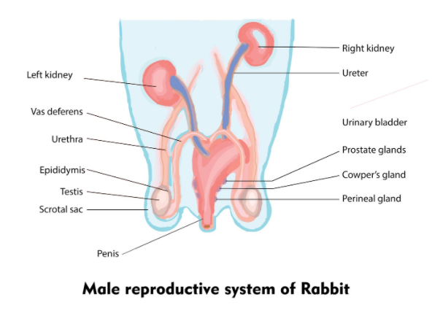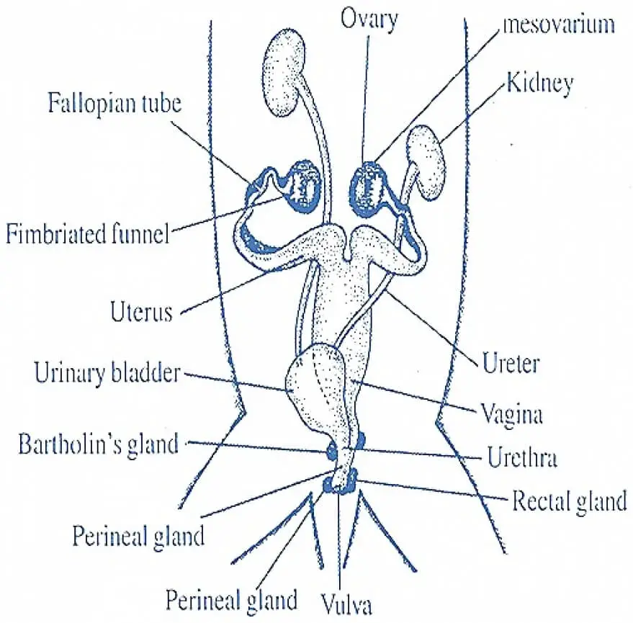

#### **2. Female Reproductive System of the Rabbit**

* **Ovaries**: Produce eggs.
* **Fallopian tubes**: Site of fertilisation.
* **Uterus**: Divided into two uterine horns (where the embryo develops).
* **Cervix**: Separates the uterus from the birth canal (vagina).
* **Birth canal** (vagina): Receives sperm and delivers young.

#### **3. Fertilisation and Development in the Rabbit**

* Fertilisation is internal (in the fallopian tubes).
* Female rabbits are induced ovulators → ovulation occurs after mating.
* Zygote forms → divides → travels to the uterus.
* Embryo implants in the uterine wall → develops internally.
* Pregnancy period: 30–32 days.
* Rabbits are viviparous (give birth to live young).
* Male rabbits may become sterile in summer due to reduced sperm count and motility.

### **6.4. Sex Determination in Humans**

### **6.4.1. Chromosomal Basis**

* Humans: 46 chromosomes (23 pairs).
* 22 pairs: autosomes; 1 pair: sex chromosomes.
* Female: XX (homogametic).
* Male: XY (heterogametic).

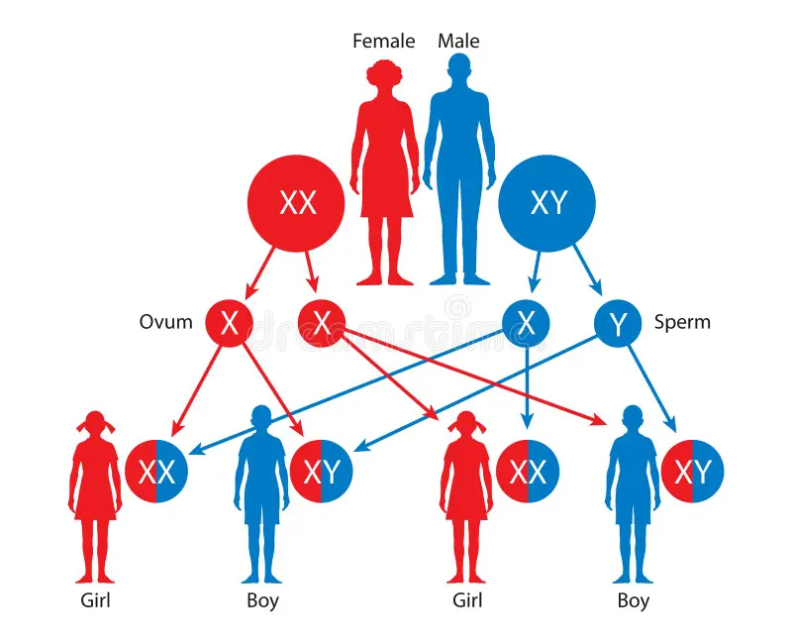

#### **6.4.2. Role of Sperm and Egg**

* Mother contributes only the X chromosome.
* Father contributes the X or Y chromosome.
* Combination:
  + XX → Female
  + XY → Male
* Therefore, the sex of the child is determined by the father.

#### **6.4.3. Probability**

The probability (chance) for a couple to have a son or a daughter during each pregnancy is 50% means there is an equal chance of a son or a daughter to be born. Since, the mechanism of sex determination in humans completely depends upon the father instead of mother, therefore, the male individual is called Sex determinator.

* Chance of a son or a daughter = 50% each.



